**Assignment No:-3**

Name:-Suryawanshi Sangramsingh Sambhaji

Batch:-April Date:-1/5/2024

**1. Display numbers from 1 to 100.**

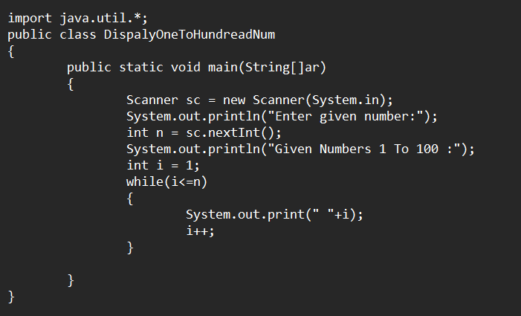

**Output:**

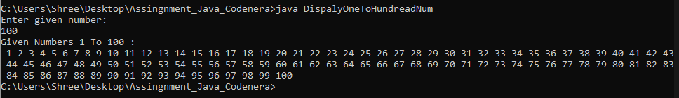

**2. Display all even numbers from 1 to 100.**

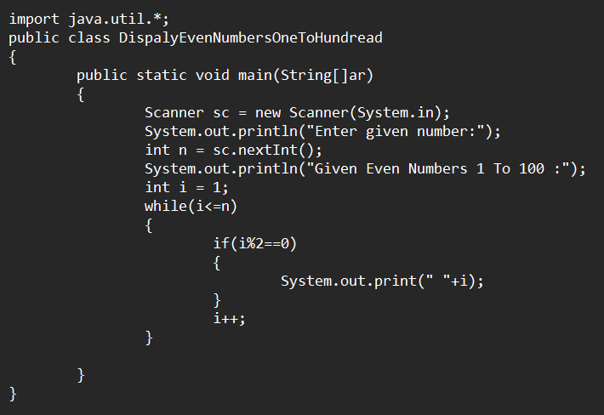

**Output:**

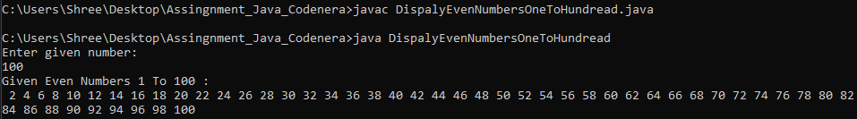

**3. Write a program to print all natural numbers from 1 to n. - using while loop.**

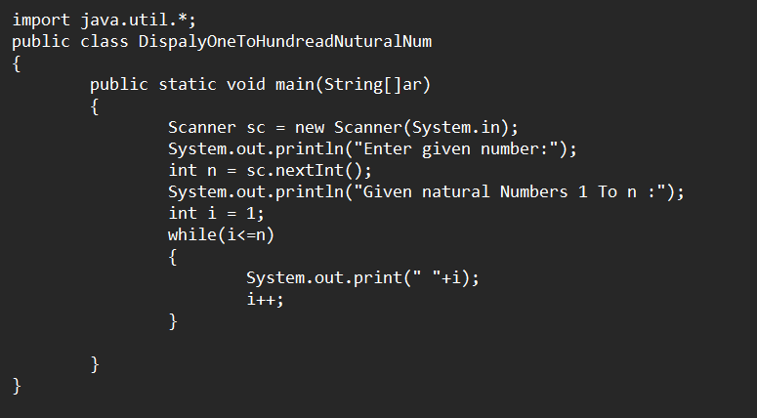**Output:**

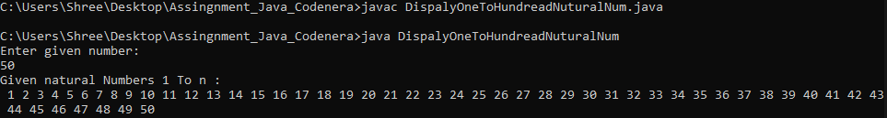

**4. Write a program to print all natural numbers in reverse (from n to 1). - using**

**While loop.**

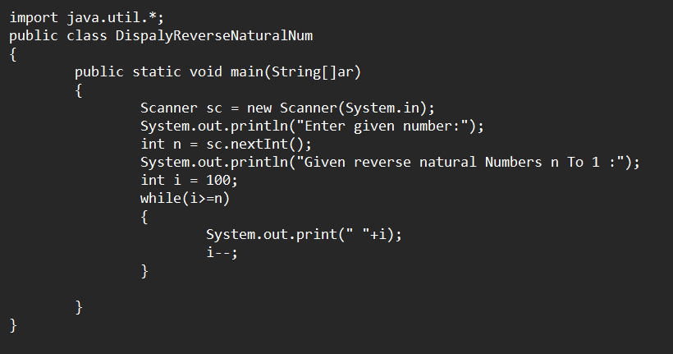**Output:**

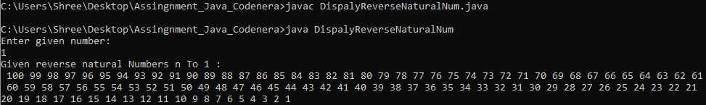

**5. Write a program to print all odd numbers between 1 to 100. - Using while**

**Loop.**

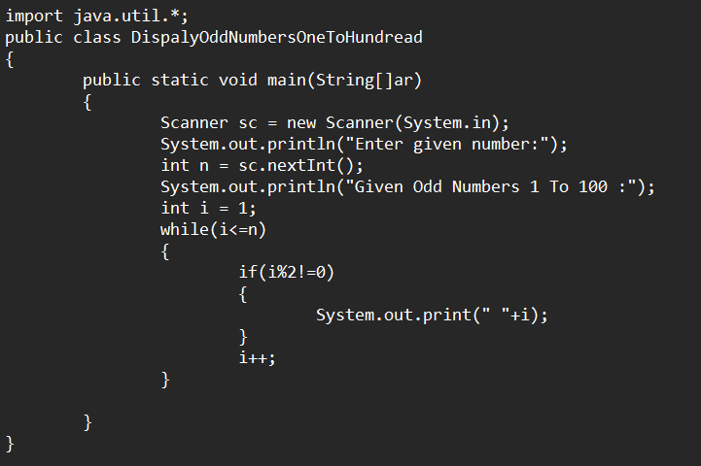**Output:**

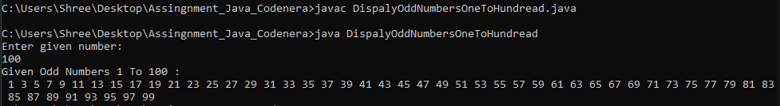

**6. Write a program to print all odd number between 1 to 100.**

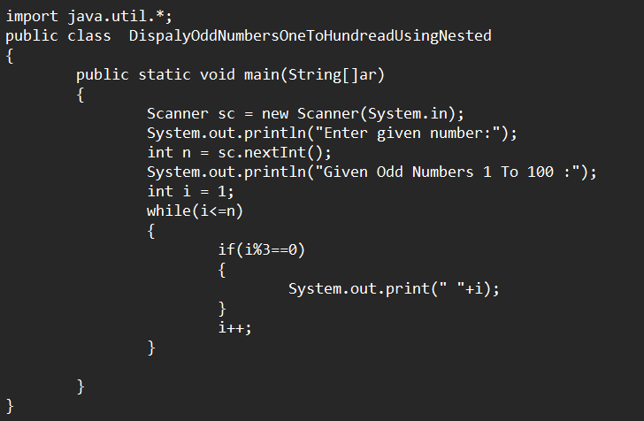**Output:**

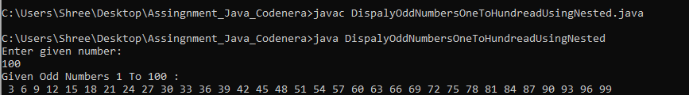

**7. Write a program to find sum of all natural numbers between 1 to n.**

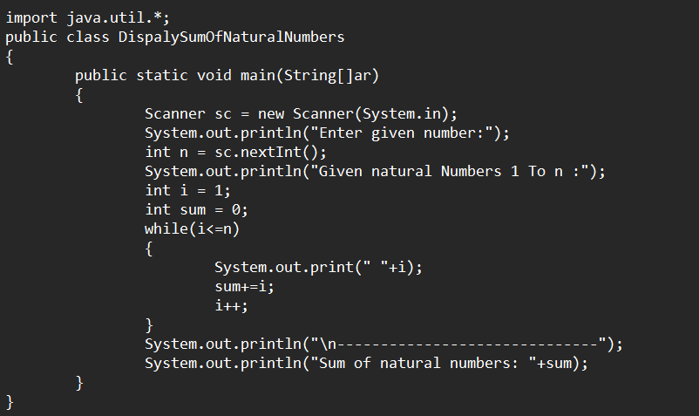**Output:**

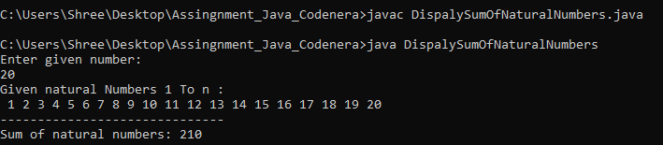

**8. Write a program to find sum of all even numbers between 1 to n.**

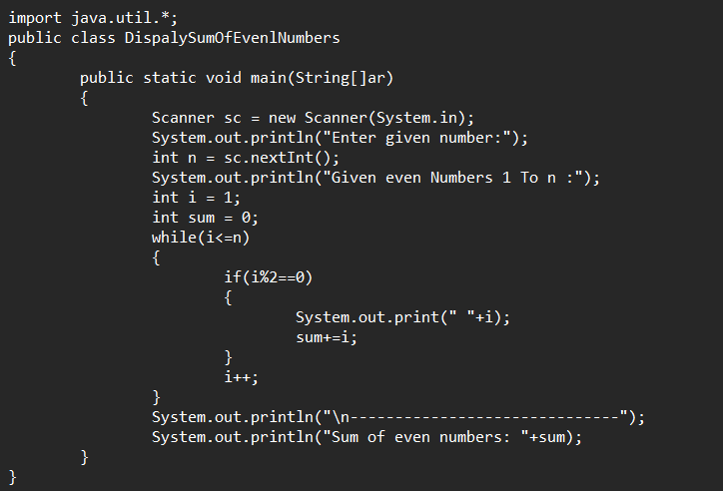**Output:**

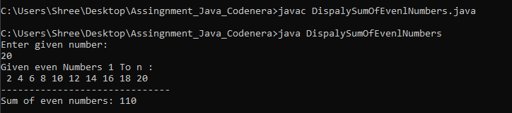

**9. Write a program to find sum of all odd numbers between 1 to n.**

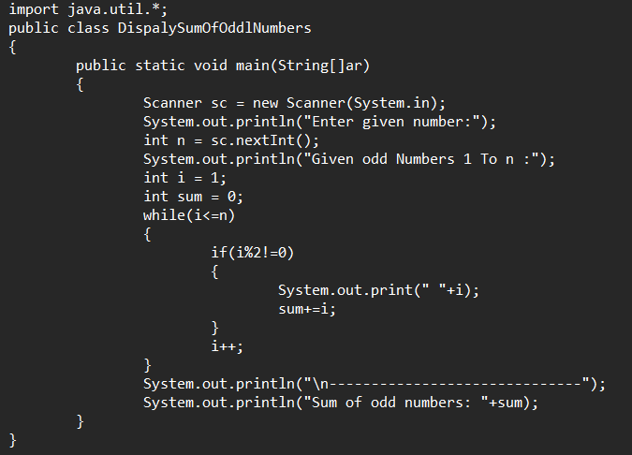**Output:**

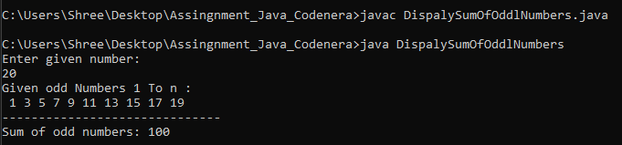

**10. Display all odd numbers from 200 to 300.**

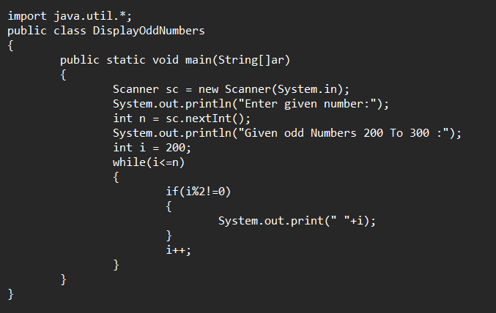**Output:**

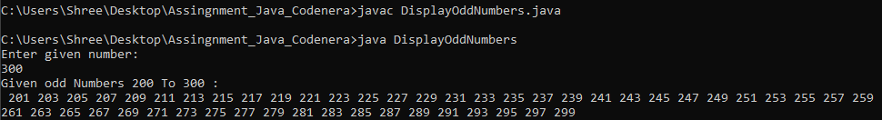

**11. Write a program enter your name and print it five times.**

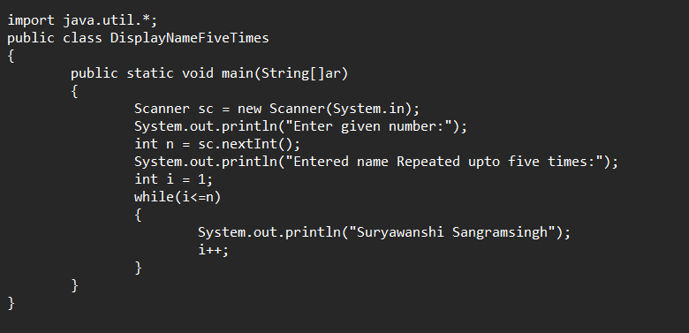**Output:**

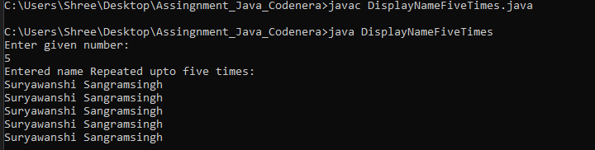

**12. Write a program take input first and last no and display all odd numbers between them and find sum and count.**

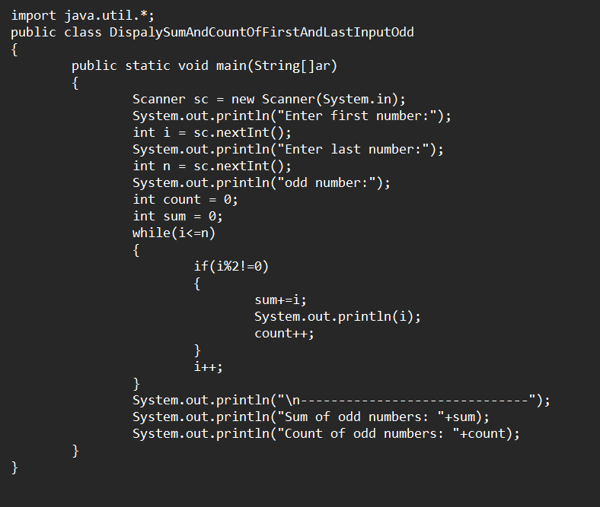 **Output:**

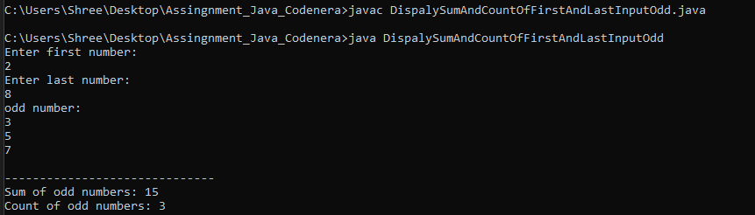

**13. Write a program take input first and last no and display all even numbers between them and find sum and find sum and count.**

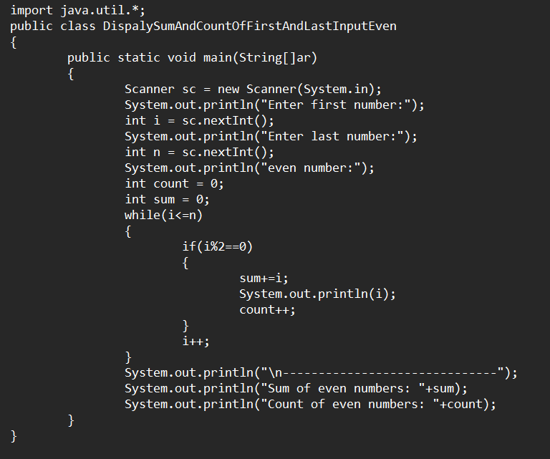 **Output:**

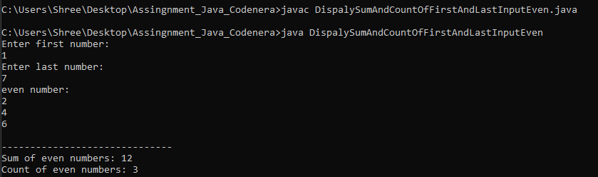

**14. Write a program to take input a no and print table.**

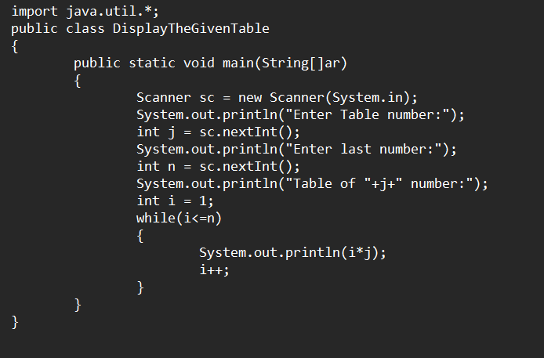 **Output:**

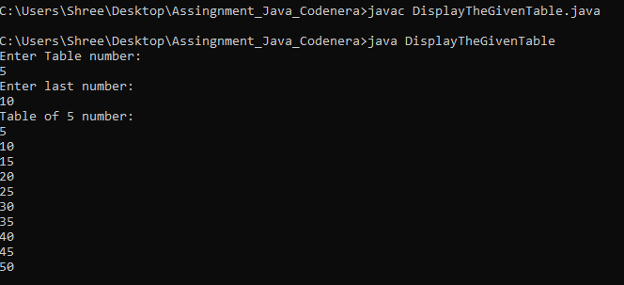

**15. Find the sum of even number of n digit number.**

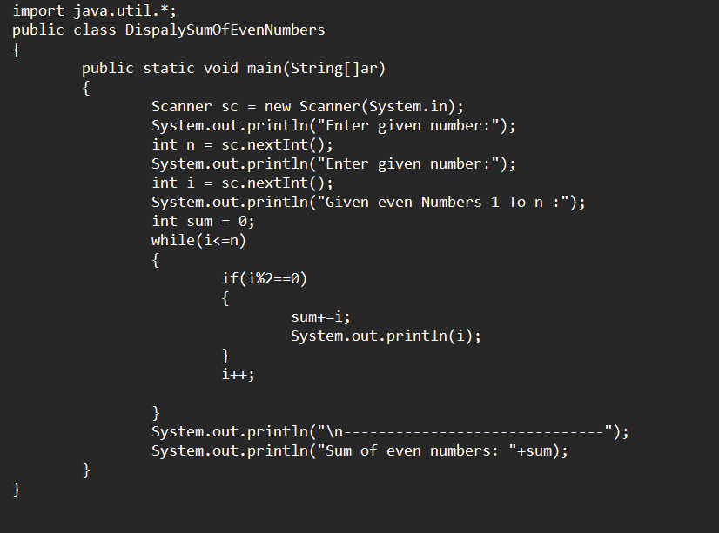 **Output:**

